SQL Tuning Example

The following example uses the Squirrel SQL Client to demonstrate the use of explain plans.

Query

SELECT CH.STD_EVENT_ID AS "StandardEventId" ,
CH.RELEASE_DATE AS "ReleaseDate",
CH.FINAL_DATE AS "FinalDate" ,
CH.EVENT_DESCRIPTION AS "EventDescription"
FROM CHANGED_EVENTS CH
WHERE CH.STD_EVENT_ID IN (
SELECT DISTINCT COE.STD_EVENT_ID
FROM CO_EVENTS COE
WHERE COE.CO_NUMBER = '050221WB' AND COE.EVENT_DATE
BETWEEN CH.RELEASE_DATE AND CH.FINAL_DATE )

Explain Plan

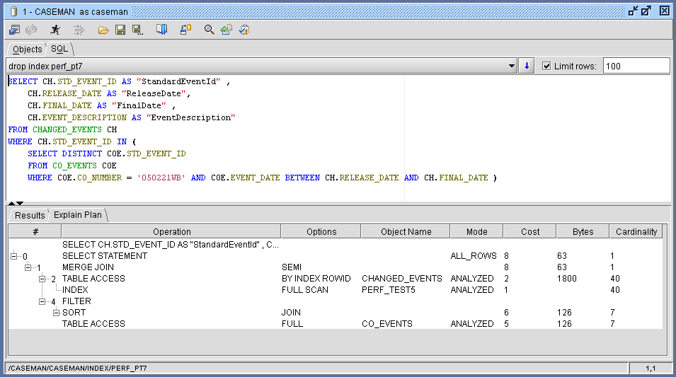

The deeper the level of indentation the earlier the operation occurs.

The explain plan shows that:
- The overall cost is 8.
- The select statement returns rows via a “merge” join on 2 rowsets. The SQL “IN” is causing 2 entirely separate rowsets to be selected and merged using a common unique key: STD_EVENT_ID.
- The first rowset comes from a table access on CHANGED_EVENTS:
  - The index “PERF_TEST5” is used to determine which rows to access and returns their ROWIDs. It is an index on the field STD_EVENT_ID.
  - Data is then read from the table using the ROWID values to go direct to the rows of interest.
- The second rowset comes from a table access on CO_EVENTS:
  - A full table scan has occurred and a filter used to apply the “where” clause.

Problems

2 suspicious operations can be identified:

- The full table scan on CO_EVENTS.
- The full scan on index PERF_TEST5. This means every item in the index has been scanned. The returned ROWIDs are then used to access every row in CHANGED_EVENTS (the “cardinality” equals the number of rows in the CHANGED_EVENTS table). In other words, this is very similar to a full tables scan and is unlikely to scale.

Resolving (1)

- A full table scan on CO_EVENTS needs to be avoided because we know that in the real environment it will contain a very large number of rows. If the table only ever contained a few hundred (or perhaps a few thousand) rows we would not tune the query.

- Check an index exists on CO_EVENTS that contains a field used by the “where” clause in the query:

SELECT DISTINCT COE.STD_EVENT_ID
FROM CO_EVENTS COE
WHERE COE.CO_NUMBER = '050221WB' AND COE.EVENT_DATE
BETWEEN CH.RELEASE_DATE AND CH.FINAL_DATE

- Using the SQL client shows that neither of these fields are indexed:

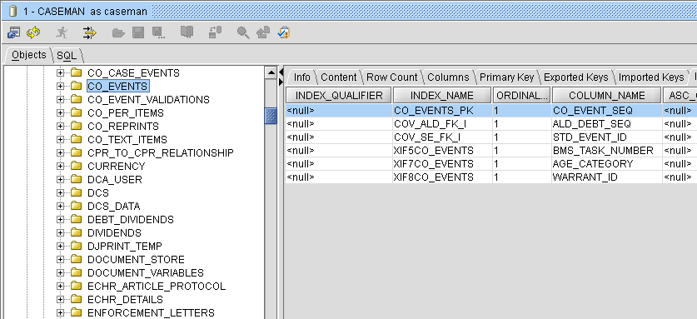

- The solution is to add an index. In this example CO_NUMBER is indexed because it is likely to be useful to other queries whereas the EVENT_DATE is not:

CREATE INDEX PERF_PT7 ON CO_EVENTS(CO_NUMBER)

- The new explain plan shows that the full table scan has been replaced by a range scan upon the index. This indicates that the index returns more than 1 ROWID – the cardinality shows that 7 ROWIDs have been selected:
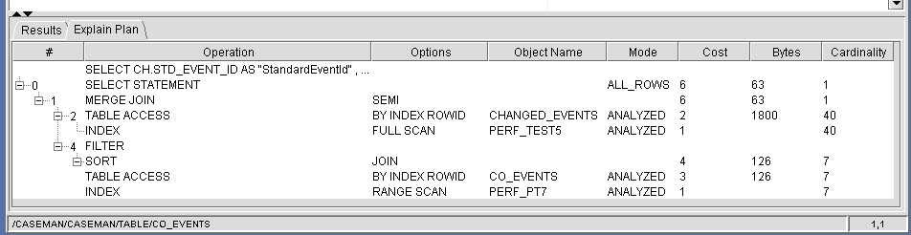

- The total “cost” for the operations associated with getting data from CO_EVENTS has also gone down from 6 to 4 – but this is not the main concern because we know that while 6 may seem a low cost it will not scale.

Resolving (2)

- An index is used but it is then used to access every row in the CHANGED_EVENTS table. This has occurred because the merge join requires the merged rowsets to be sorted by the key field, STD_EVENT_ID. The Cost Based Optimiser has worked out that selecting all ROWIDs in the index is cheaper than a full table scan – the reason is that a full table scan would require a “sort” operation over all rows whereas the index entries are already sorted.

- In CaseMan CHANGED_EVENTS is not one of the larger tables so we may choose not to tune this query.

- However, there are 2 options for tuning:
  - Find a way to rewrite the SQL that avoids the use of “IN” – it is causing the merge join and therefore the table access on CHANGED_EVENTS.
  - Avoid accessing the table altogether.
If all of the fields selected from a table appear in the index used to find the ROWIDs to access the table then the table does not have to be accessed at all – the selected data comes from the index. In this case:

CREATE INDEX PERF_PT12 ON CHANGED_EVENTS(STD_EVENT_ID, RELEASE_DATE, FINAL_DATE, EVENT_DESCRIPTION)

Which gives the explain plan:

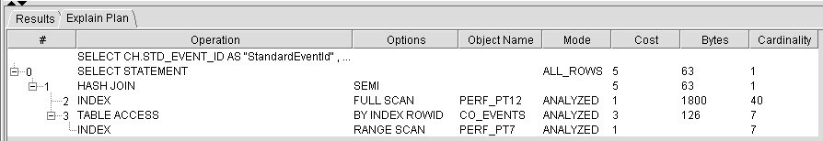

Showing that a full index scan can be very efficient. The original cost of the query was 8, it is now 5.

- Warning: The above technique for avoiding accessing the table can lead to a large number of very specific indexes being created. This would be bad for performance if the tables concerned were updated often. It is usually best to create a small number of highly reusable indexes.

